**Export Drive, Fulwood Ind Estate. Sutton in Ashfield. Notts. NG17 6AF**

**01623 441440 liz@tpsgroupltd.com**

**SERVICED/FLEXIBLE OFFICES TO LET**

TPS Small Business Park offers smart and secure “serviced offices” with easy access to the M1 (junction 28) as a cost effective approach to your office space requirements. These can be rented from a minimum of 3 months, with business rates, heating, lighting and service charges all included in the rental.  
  
The offices have been developed in order to accommodate a range of different types of business. The site has its own secure parking and other benefits.

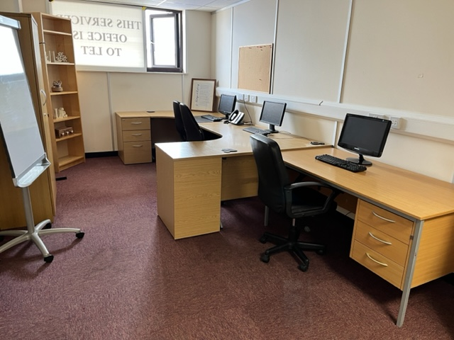

Office No 7 (vacant / 1st Floor)

Measure - 5.618m  x 2.99  =  16.82 m2     Front (North facing aspect))

**Flexibility**

* Short and long-term agreements available.
* Rent, rates, water, heating and service charge included in your rental

**Security**

* Smoke and intruder detection systems
* CCTV monitoring on entrance and throughout the site

**Accessibility**

* Access 6 days a week (Sundays by appointment)
* Extended hours access - by arrangement

**Facilities**

* Manned Reception
* Meeting room
* 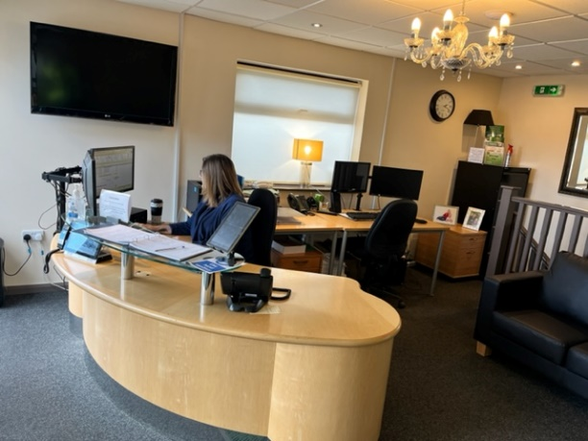Carpeted floors
* Office Furniture
* Kitchenette
* Secure WIFI
* Deliveries & despatches signed for on your behalf
* Access to Xerox Workcentre 7210 printer / copier

Meeting / Training Room

Business self storage units are also available on site and are ideal for storing archiving, equipment or stock. So, you can always maximise your office space, whilst keeping files, samples and stock close to hand.  
  
Ideal for small businesses, having sufficient resources to operate your business seamlessly whilst also controlling running costs can be a tough challenge.

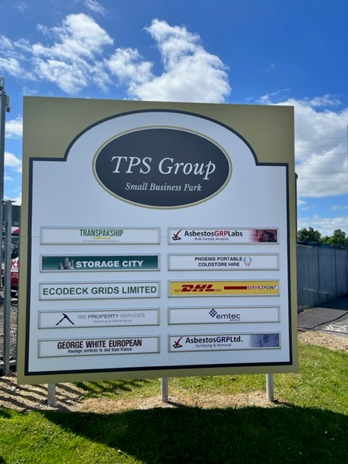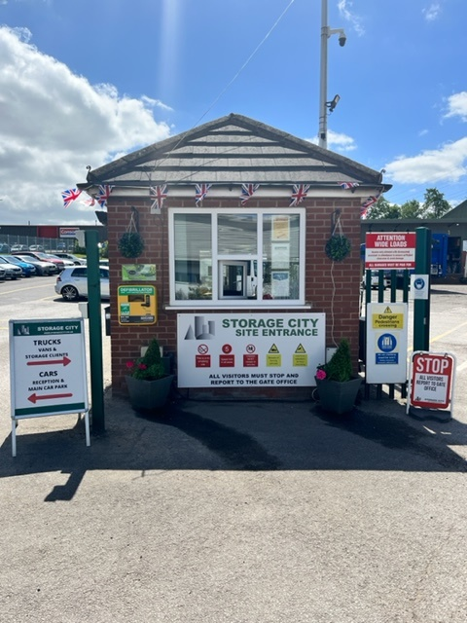

Site Signage Manned Gate Office

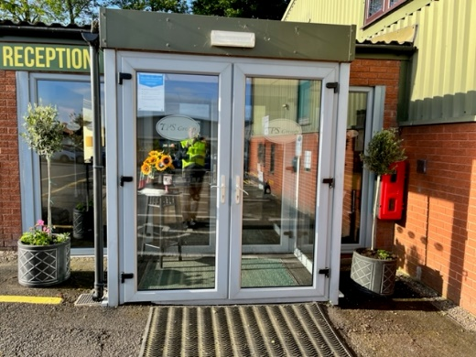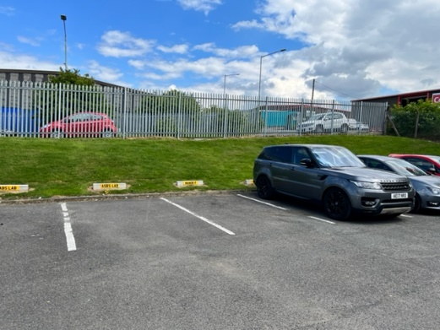

Reception Dedicated Secure Parking

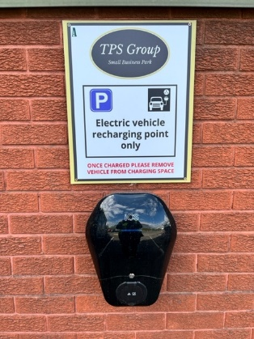

**Electric Car Charging Points**

**Support Services**

We recognise this and offer a range of services to support your business:

* Forklift Truck Services
* Various On-site units available with 24hr access
* Deliveries and collections overseen
* Change unit size whenever you need to
* 2 months’ notice to vacate

Price is £375 pcm. and includes utilities and business rates

A refundable bond equivalent to 1 months’ hire would be charged on commencement.

Storage City flexible office package offers an unbeatable small business service package and we'd be happy to talk to you about your specific requirements.

All prices are subject to VAT at the current rate and payable one month in advance.

TPS is a family business that likes to offer the ‘personal touch’ to our services and business support. We are people who like to find solutions to your requirements and are therefore eager to accommodate your business on our site. Our location just 2 minutes from M1 junction 28 enables us to be favourably placed for ease of access especially into cities like Nottingham, Derby, Leicester and Sheffield etc.

We would delight in being of service to you.

Should you require any further information then please do not hesitate to contact us.

**Names that you will recognize who use our services....**

